

ACF Lab 3

Introduction to EC2

____________________________________________________

COS 20019- Cloud Computing Architecture

Nguyen Manh Dung

20/5/2023

So this is my screenshot for Lab 3, including explanation in every image.

Task 1: Lauch Amazon EC2 Instance.

5. Select Services, Compute, and then EC2 in the AWS Management Console.

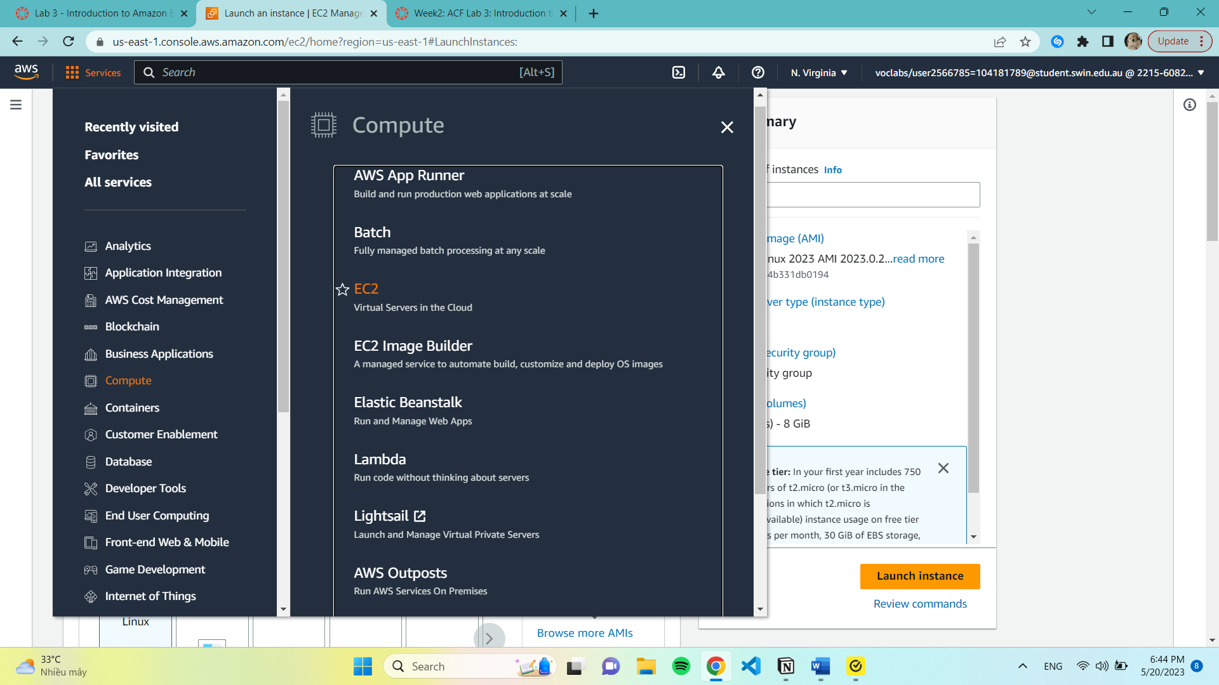

6. Choose Launch instance menu and select Launch instance

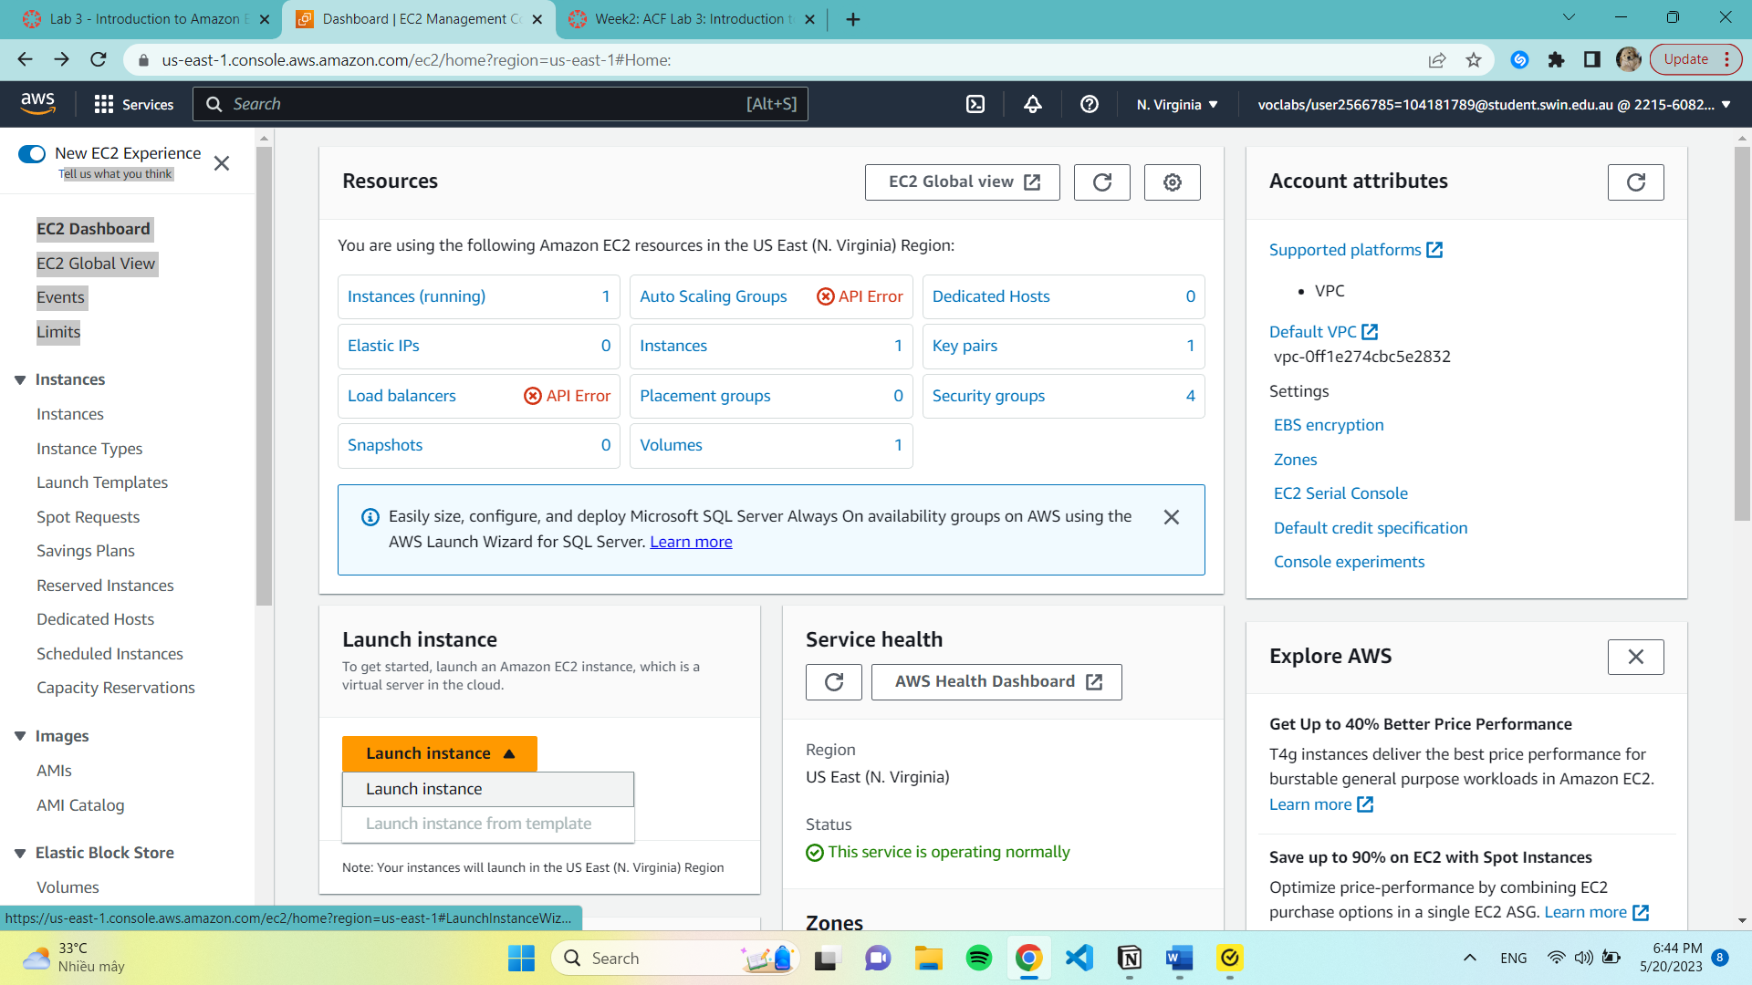

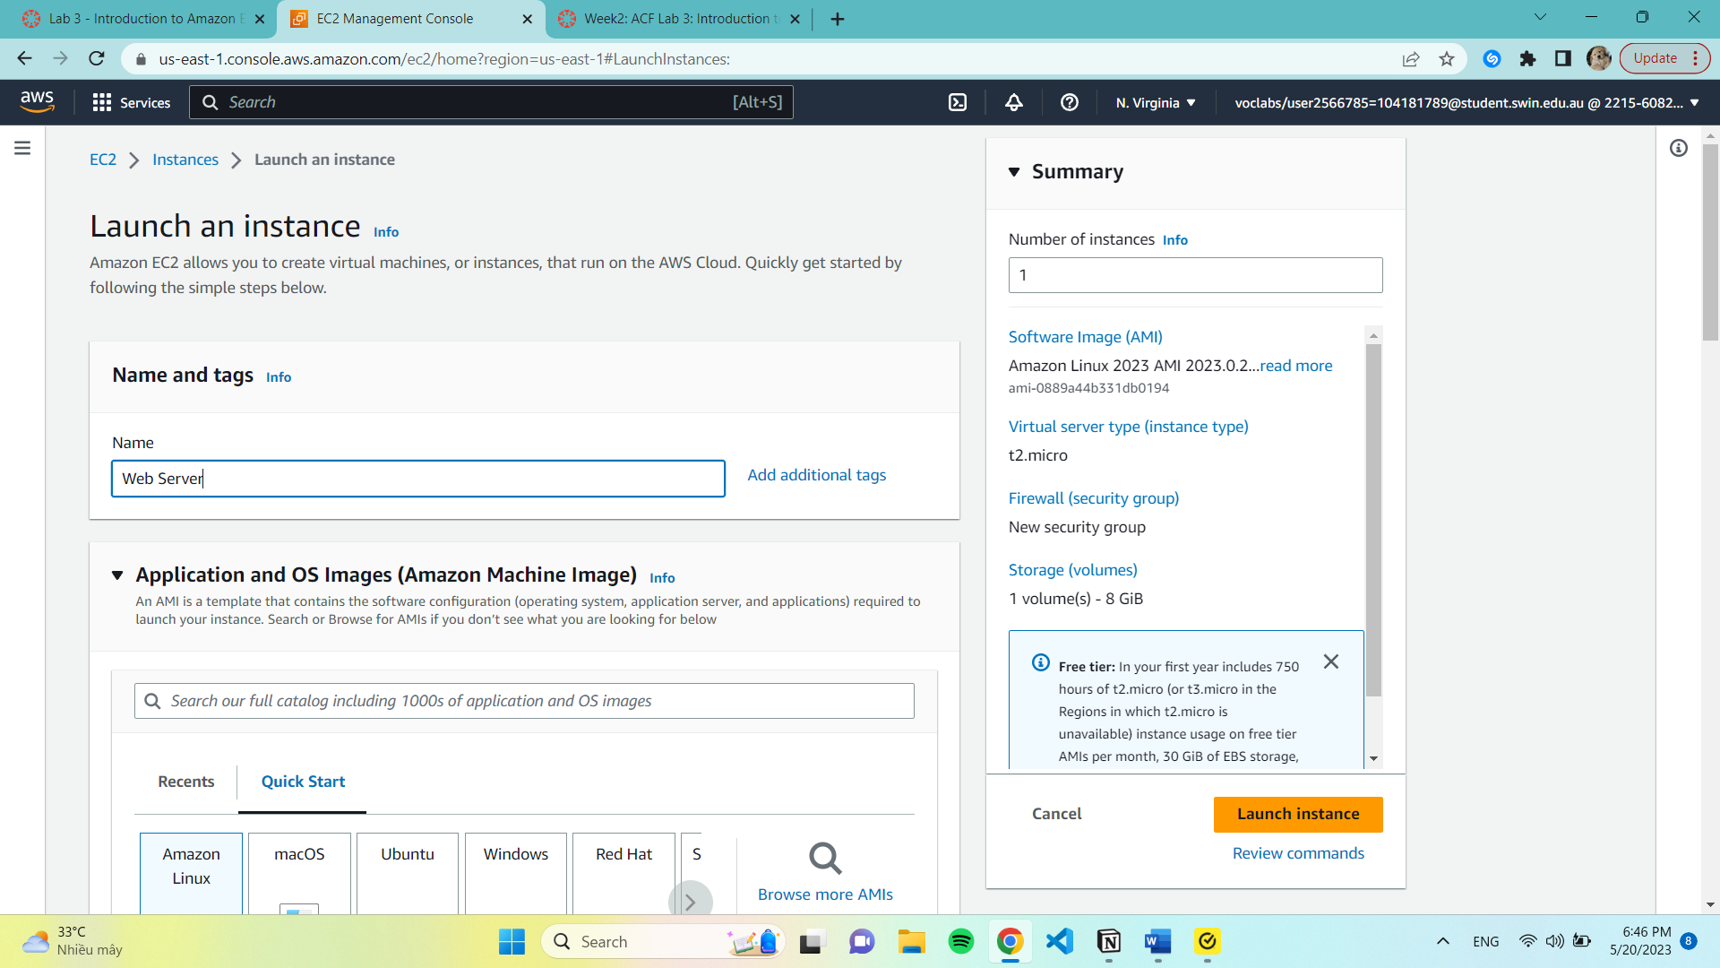

Step 1: Name and tags

7. The name “Web Server” will be stored as a tag. Tags enable us to categorize our AWS resources in different ways. The tag be created will consist a key called Name with a value of Web Server.

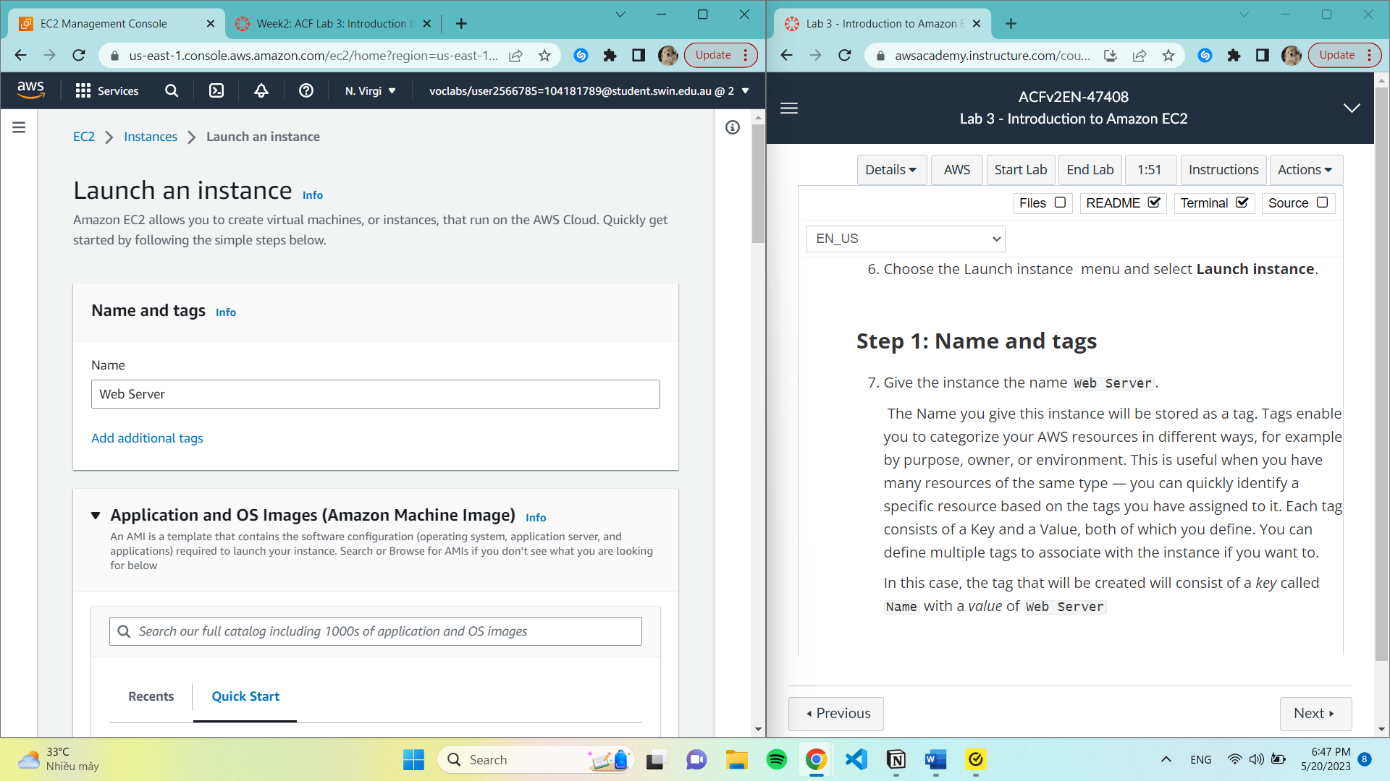

Step 2: Application and OS Images (Amazon Machine Image)

9. An Amazon Machine Image (AMI) provides the information required to launch an instance, which is a virtual server in the cloud.

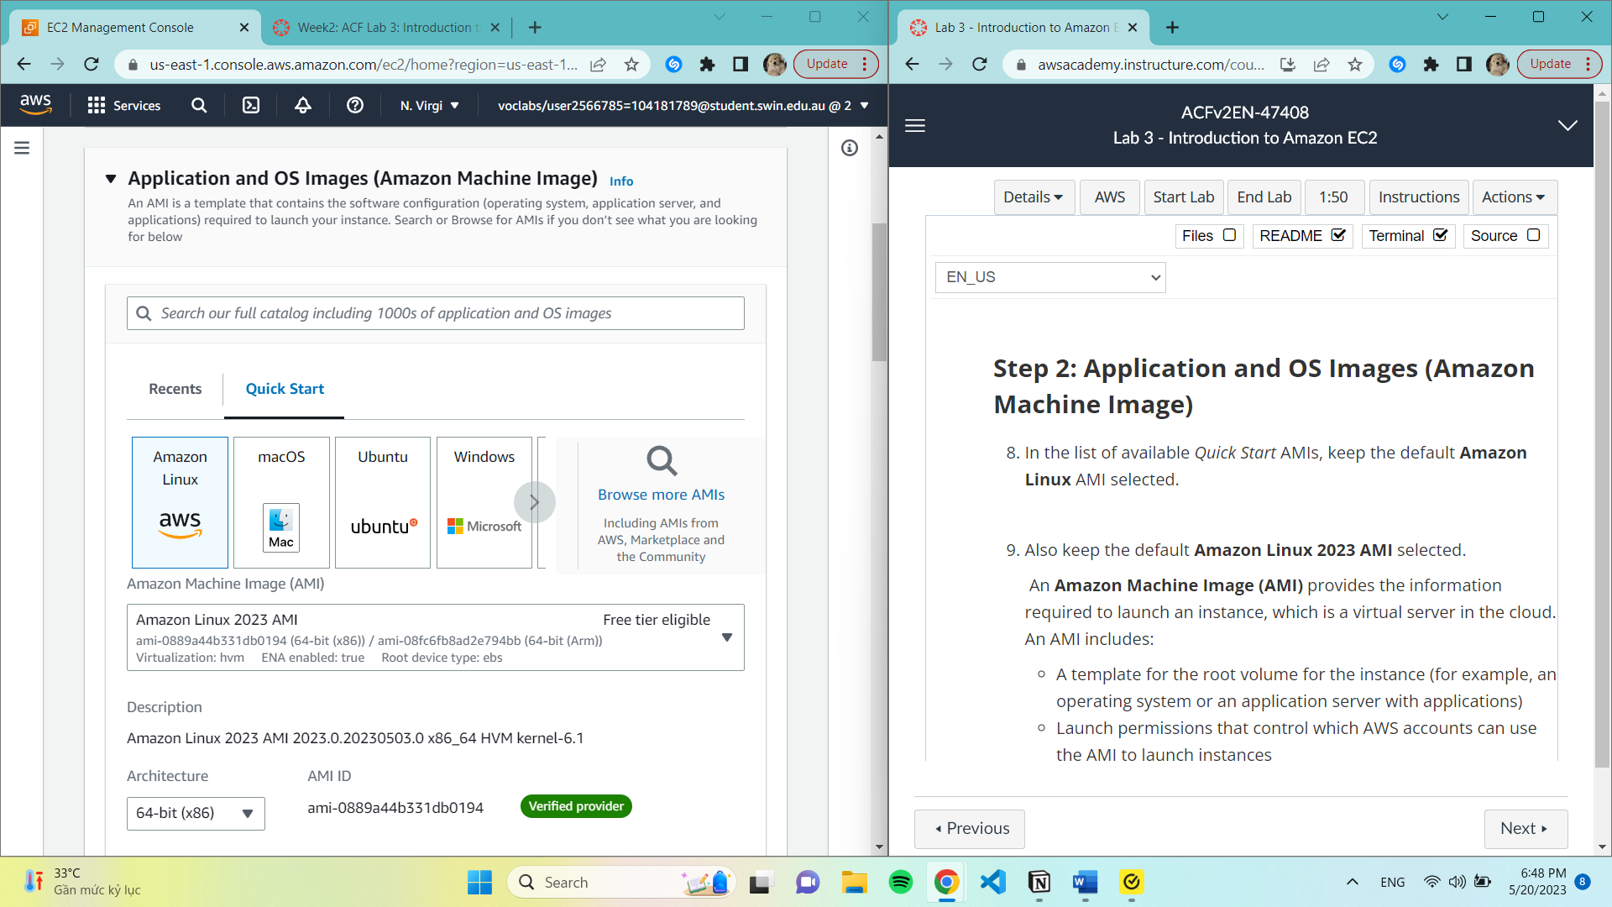

Step 3: Instance Type

10. t2.micro in ‘Instance type’ panel is selected.

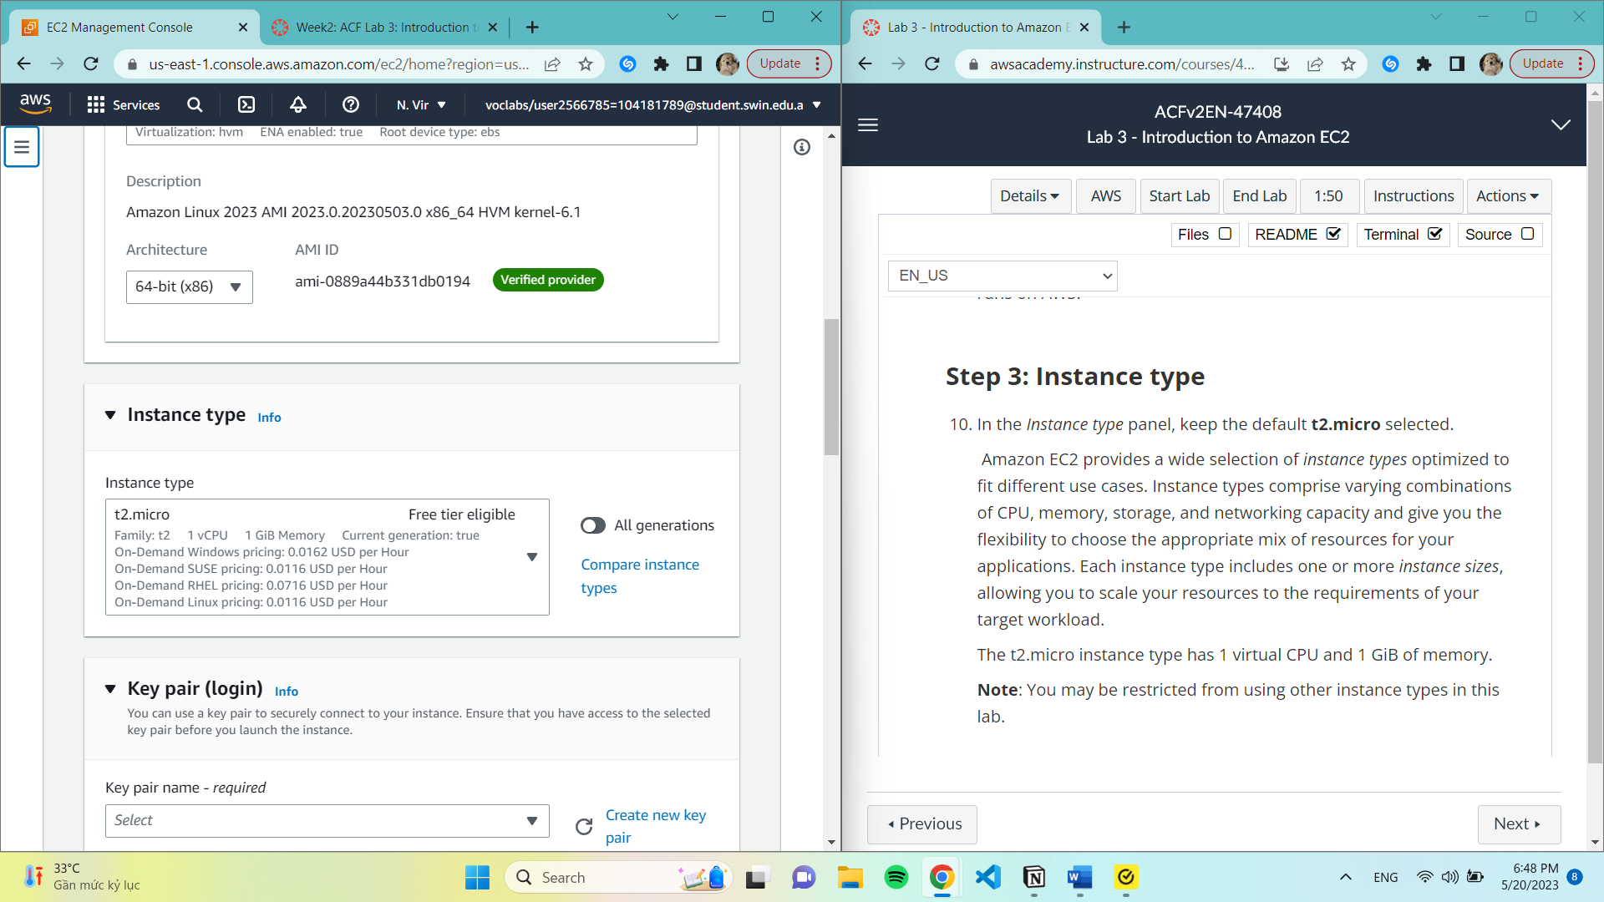

Step 4: Key pair (login)

11. For Key pair name - required, choose vockey.

To make sure you can log in to the guest OS of the instance you build. A block device mapping that designates the volumes that will be attached to the instance when it is started.

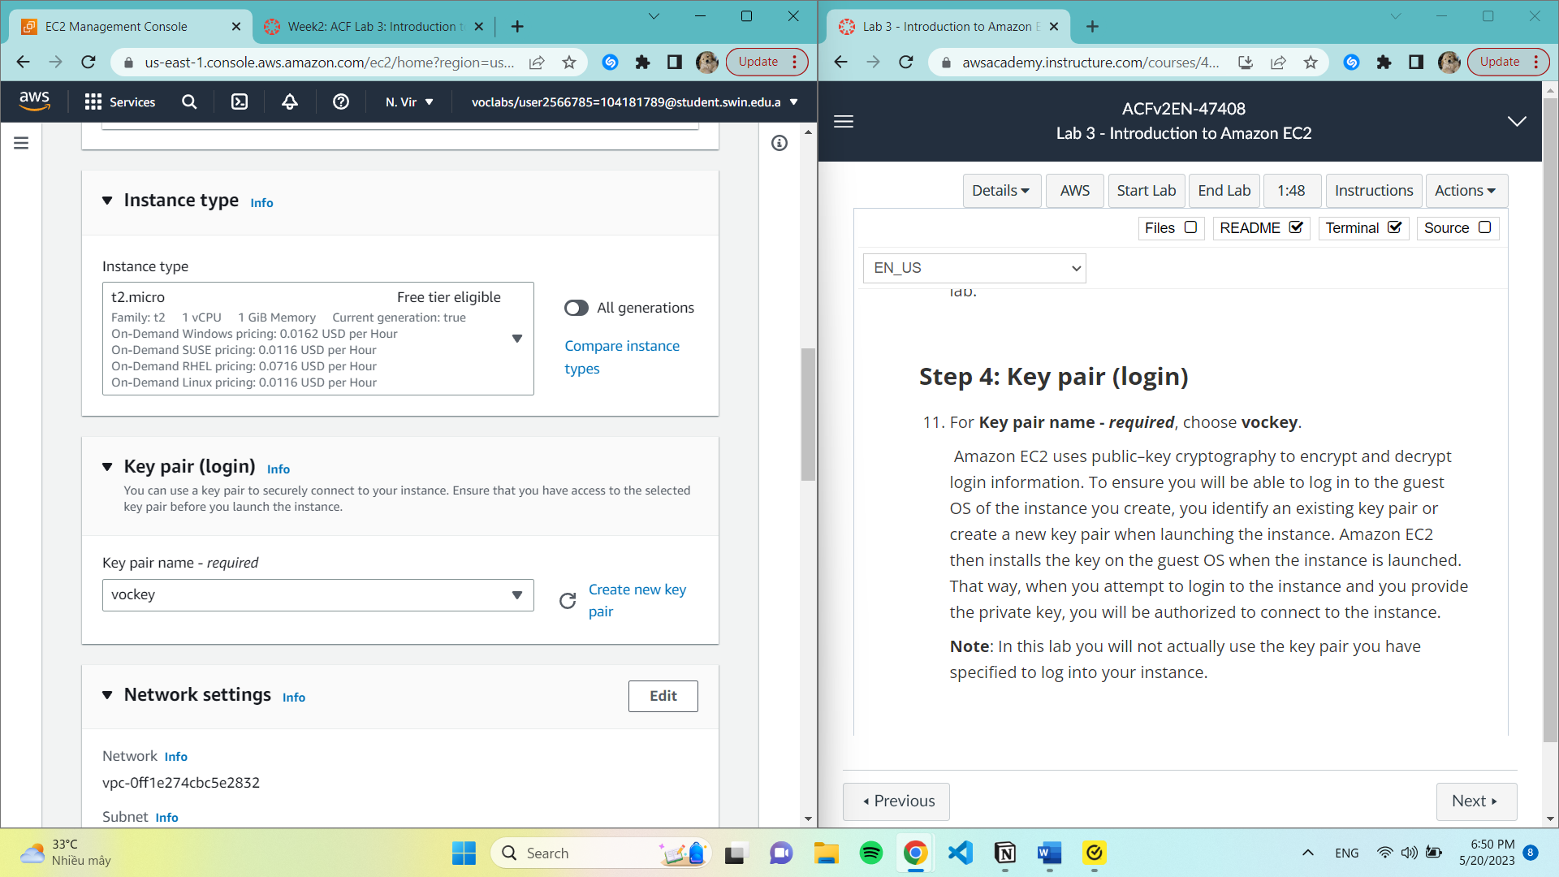

Step 5: Network Settings

Edit and select Lab VPC. The Lab VPC was created using an AWS CloudFormation template during the setup process of our lab.

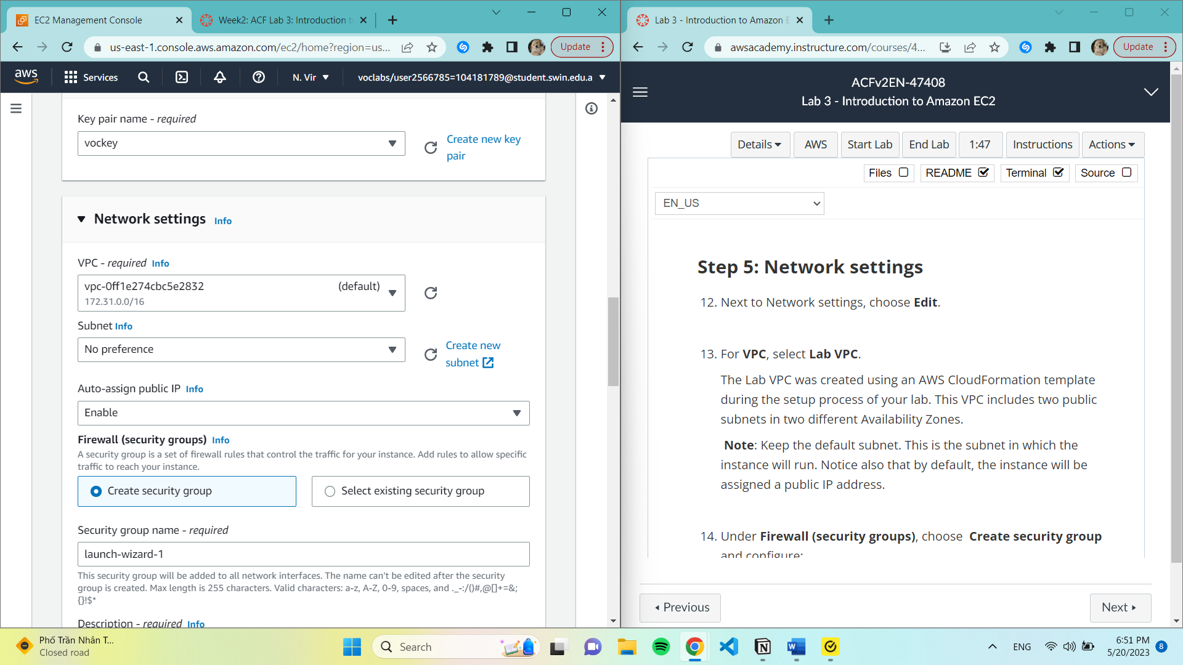

14. Under Firewall (security groups), choose Create security group and configure:

Security group name: Web Server security group

Description: Security group for my web server

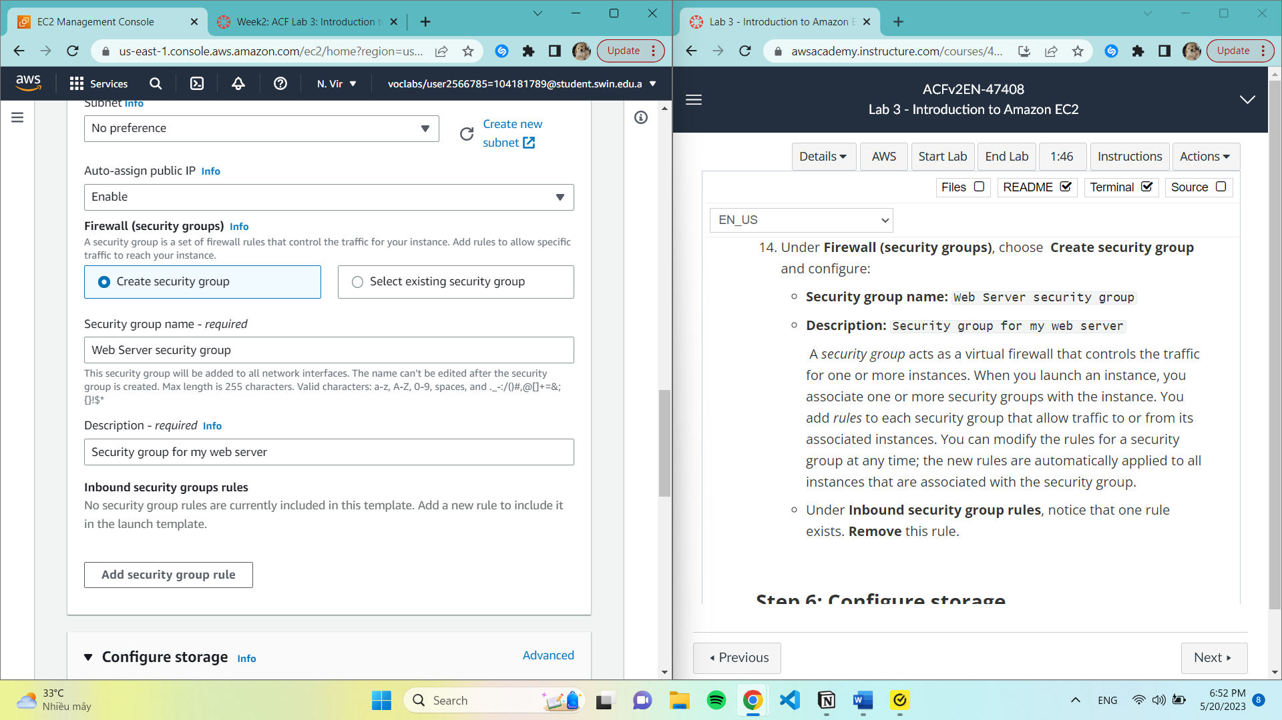A security group acts as a virtual firewall that controls the traffic for one or more instances.

Step 6: Configure Storage

Keep default settings.

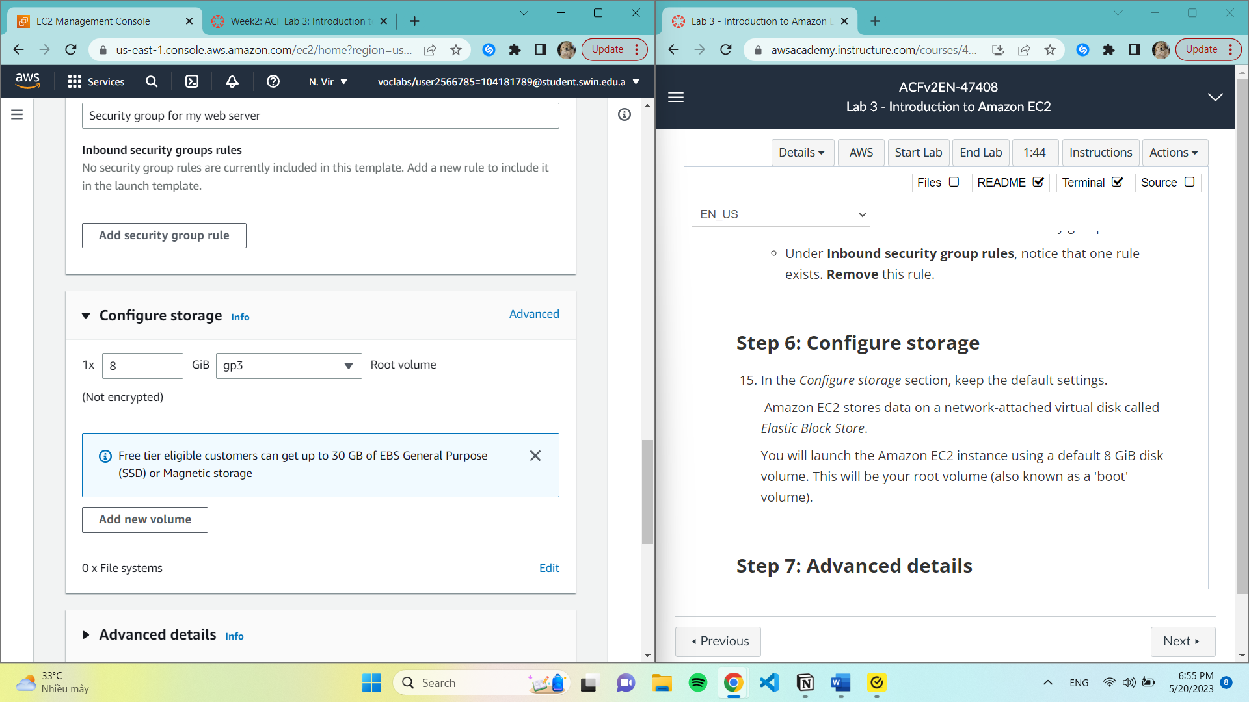

Step 7: Advanced details

Enable ‘Terminal protection’

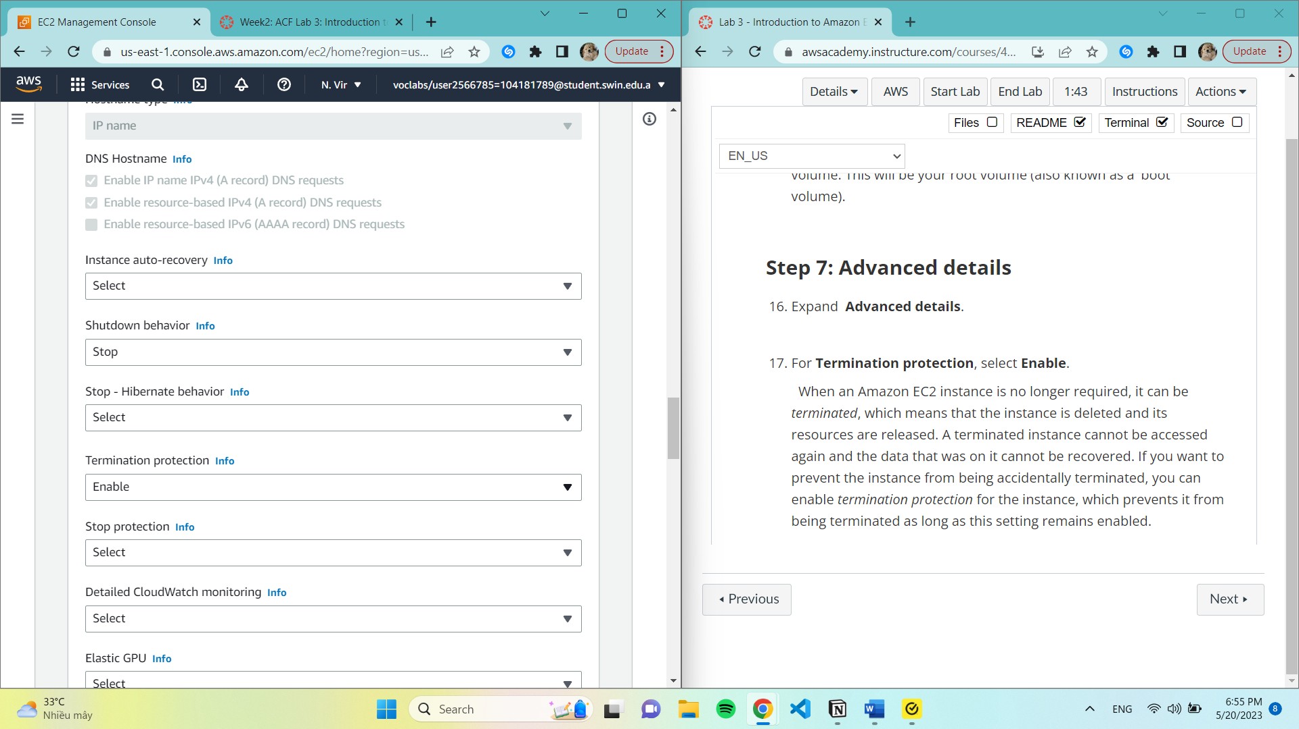

18. Add code to Data box

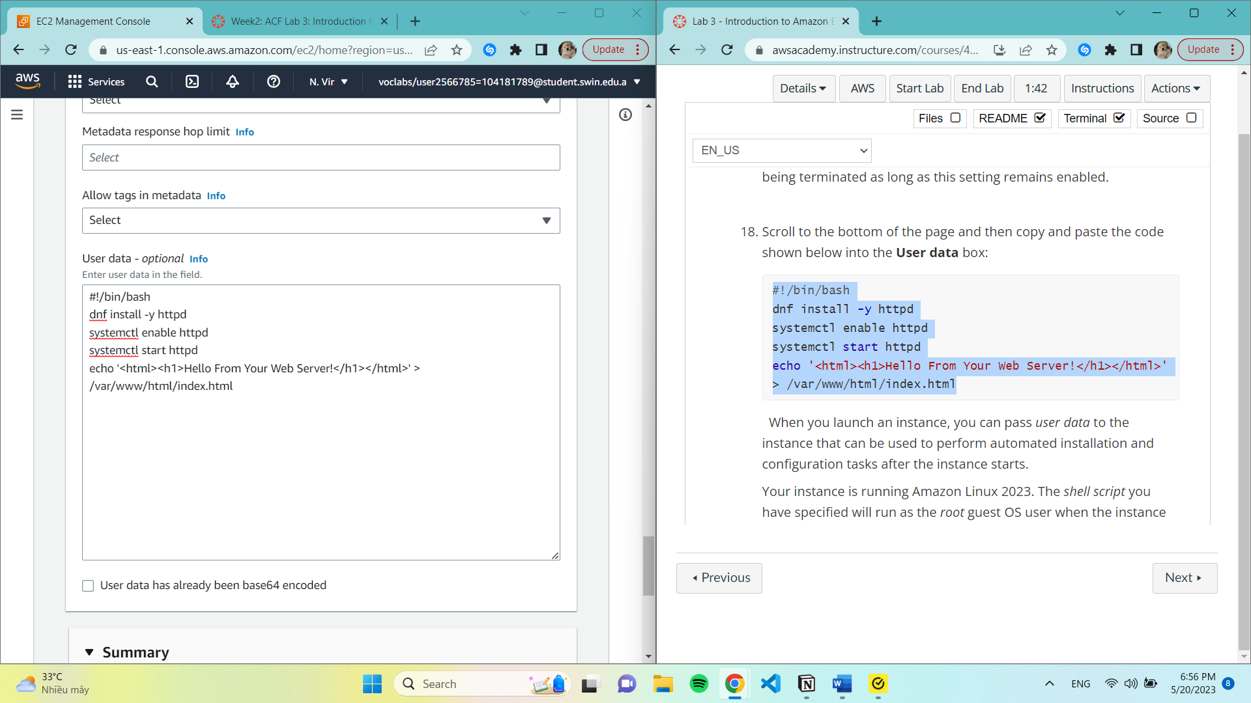 When we launch an instance, we can pass user data to the instance that can be used to perform automated installation and configuration tasks after the instance starts.

Step 8: Launch the instance

Success message included

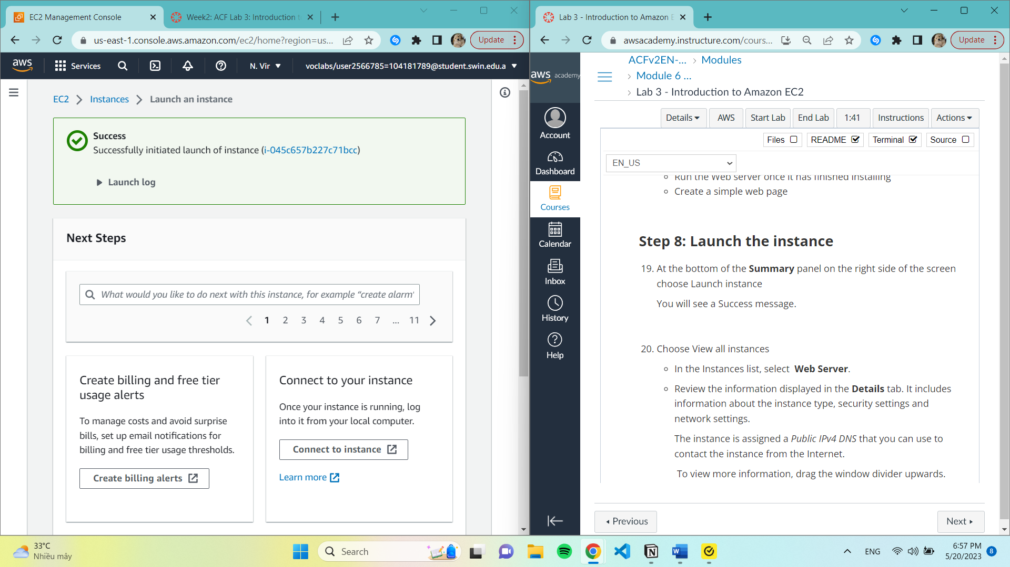

20. View all instances

Review all information.

The instance is assigned a Public IPv4 DNS that you can use to contact the instance from the Internet. To view more information, drag the window divider upwards. At first, the instance will appear in a Pending state, which means it is being launched. It will then change to Initializing, and finally to Running.

Instance will display:

Instance State: Running

Status Checks: 2/2 checks passed.

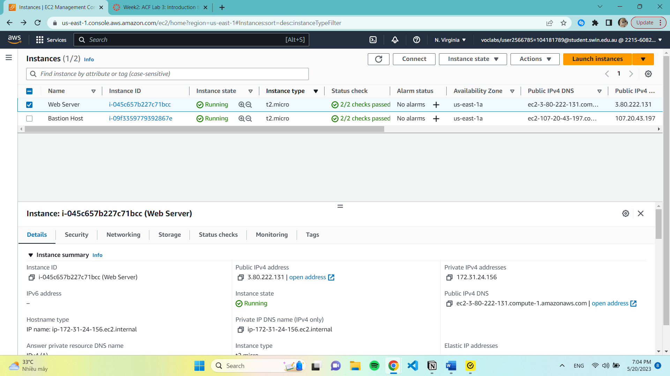

Task 2

22. Status checks tab:

both the **System reachability** and **Instance reachability** checks have passed.

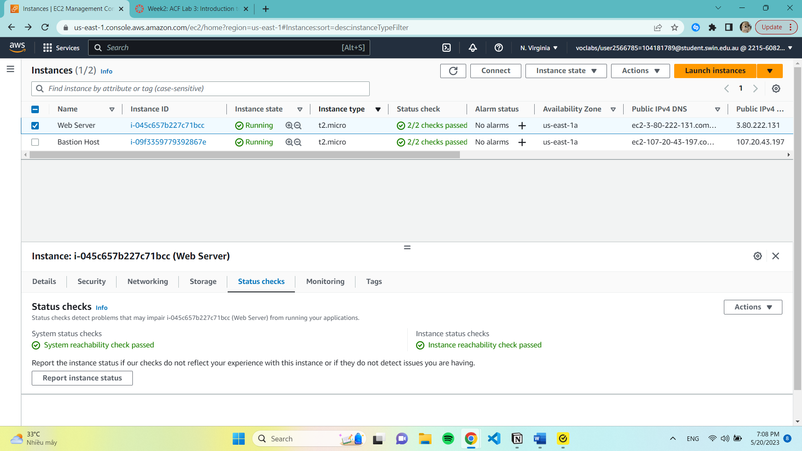

23. Monitoring tab

This tab displays Amazon CloudWatch metrics for your instance.

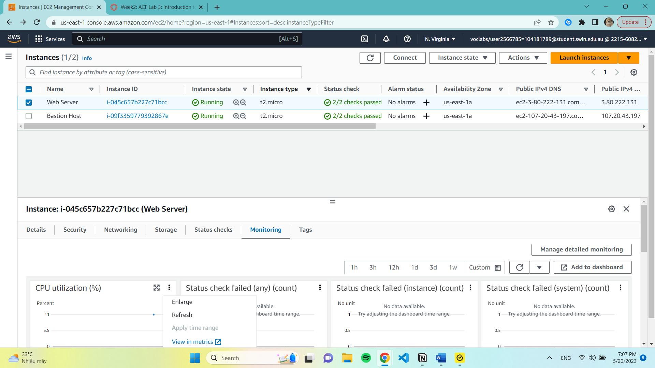

24. Monitor and troubleshoot -> Get system log.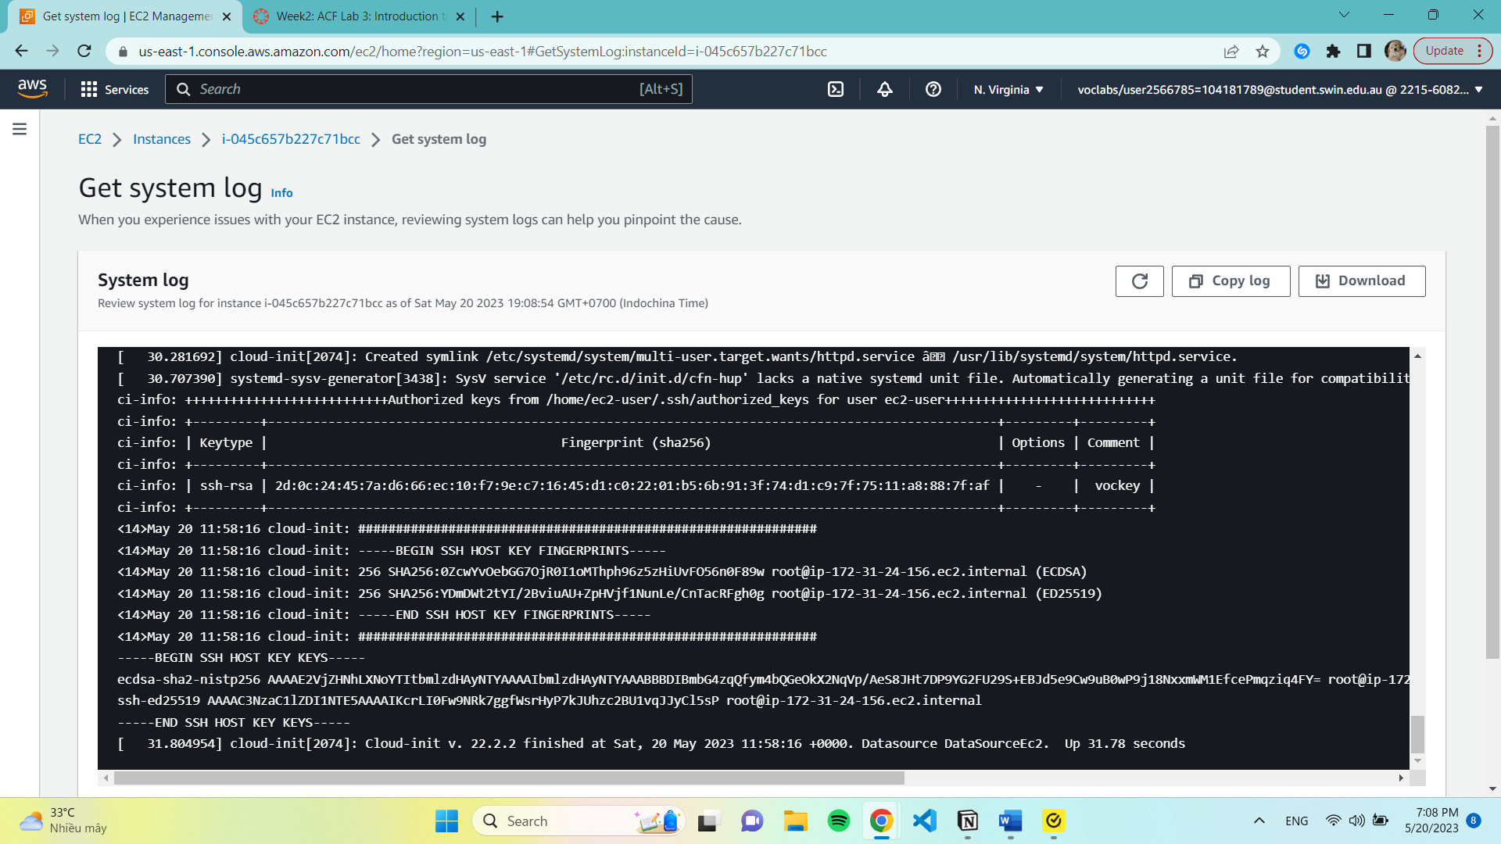

27. in the Actions menu, select **Monitor and troubleshoot Get instance screenshot.**

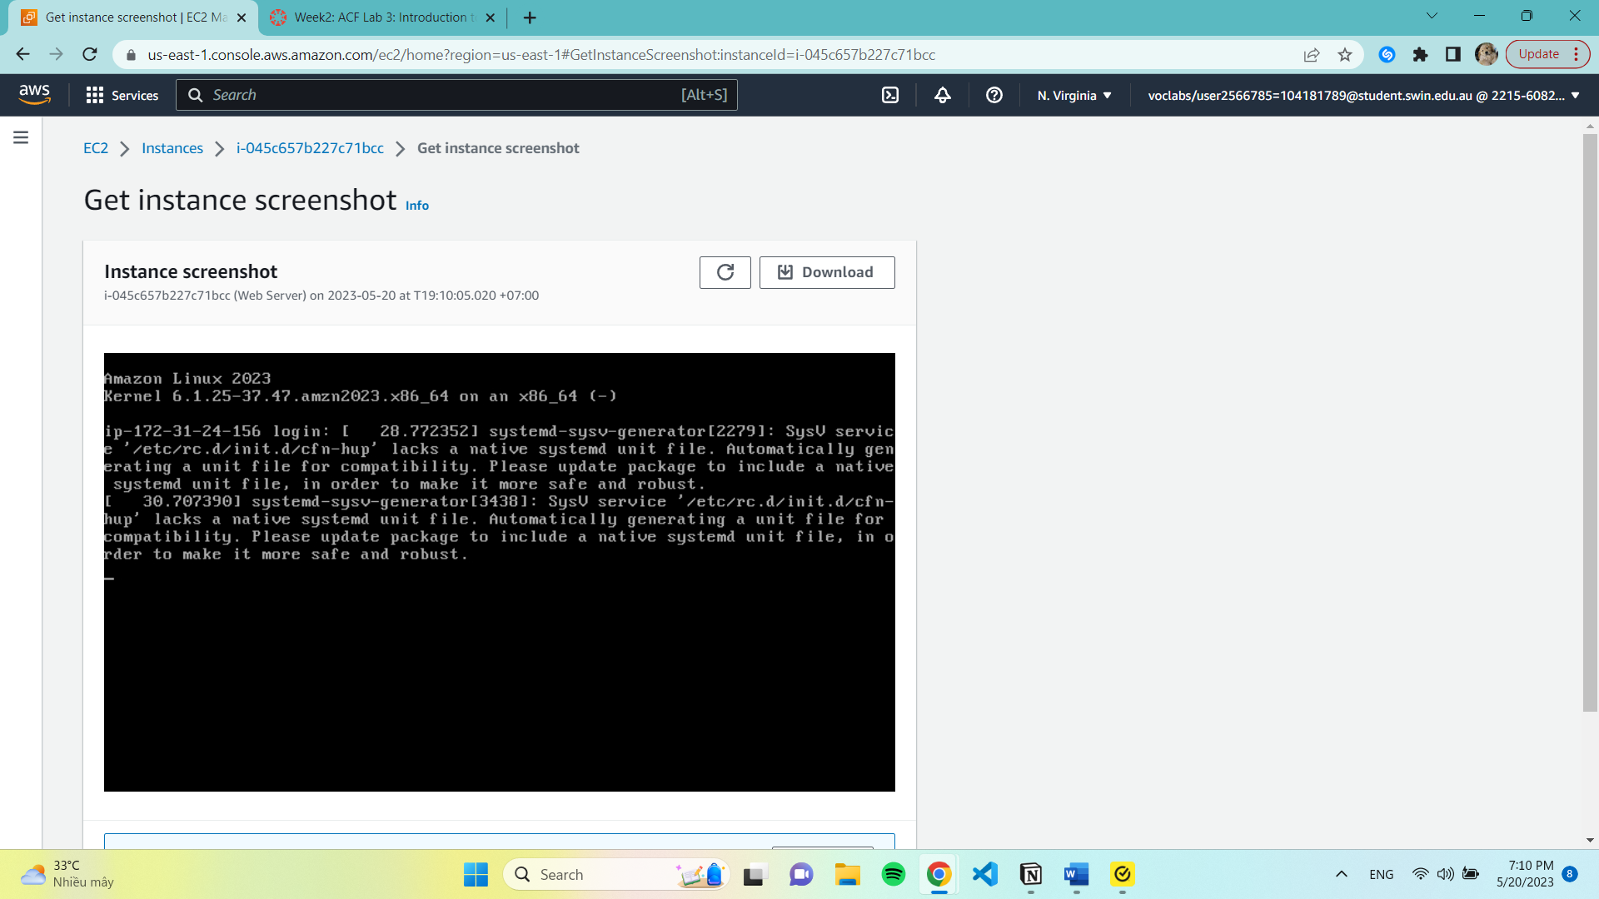

Task 3: Update Your Security Group and Access the Web Server

33. Choose Security Groups.

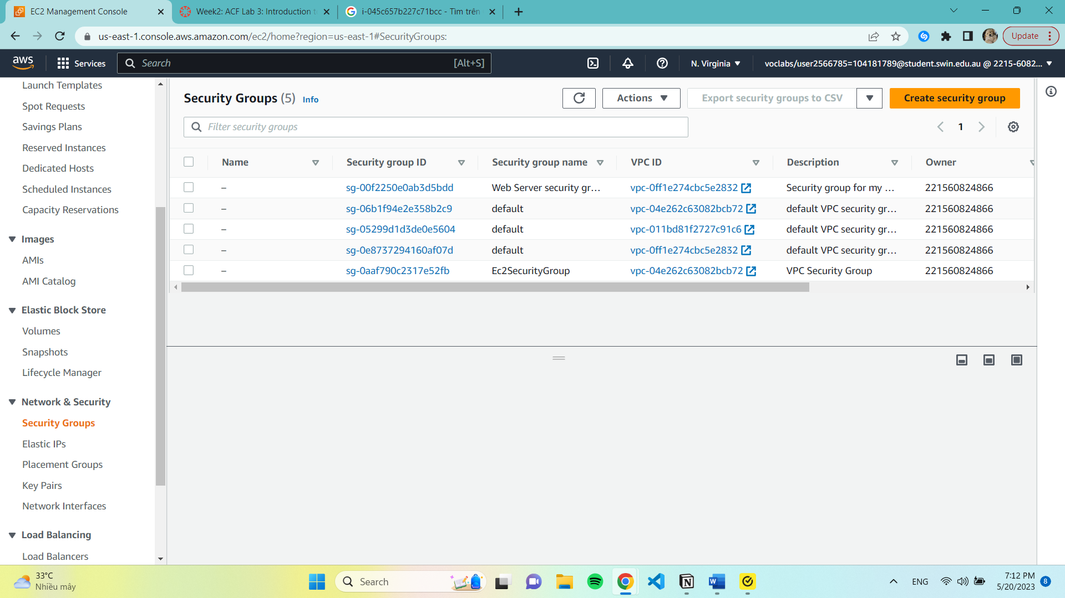

25. Create Inbound rules

Type: HTTP

Source: Anywhere-IPv4

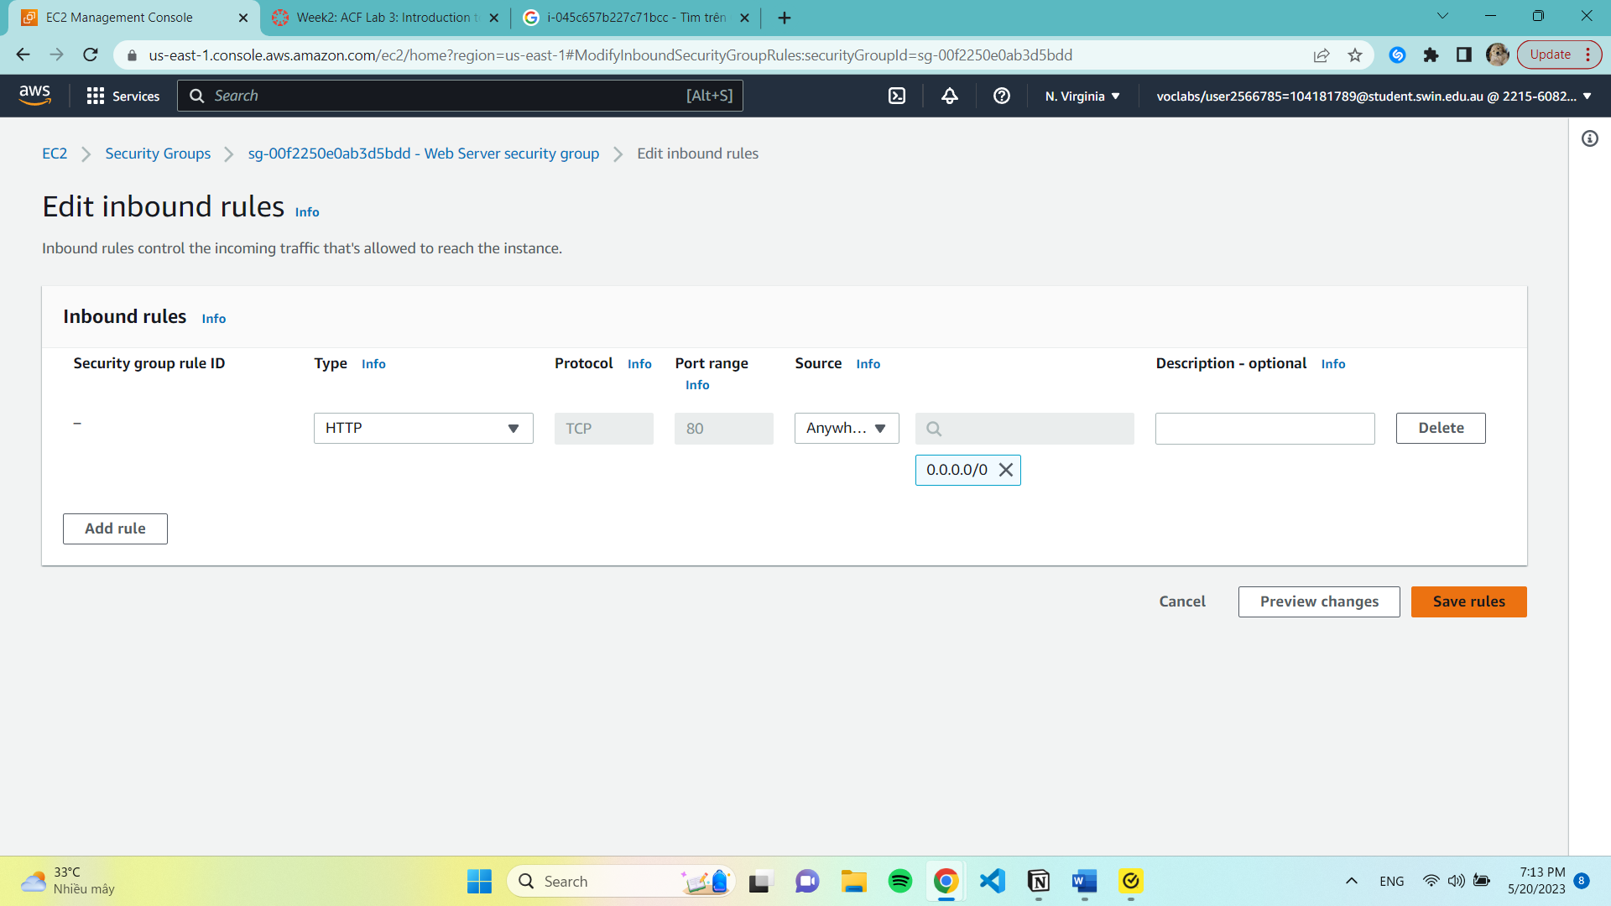

33. Reopen to web server.

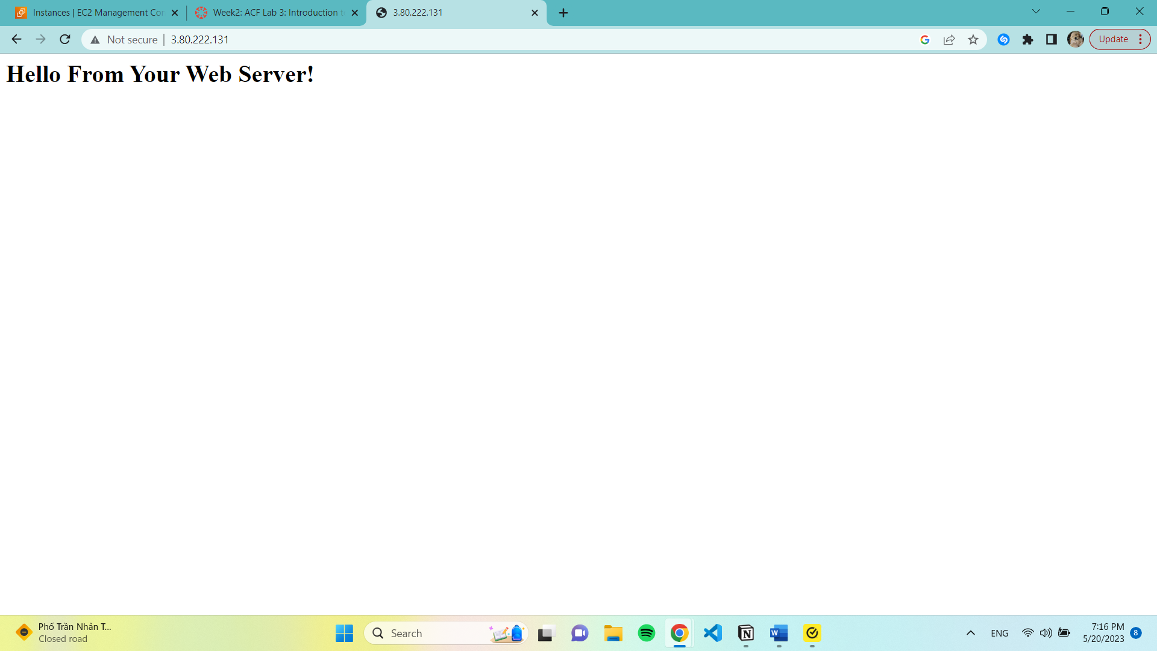

Task 4: Resize Your Instance: Instances Type ans EBS Volume

We have to stop our instance. The Instance state will display ‘Stopped’

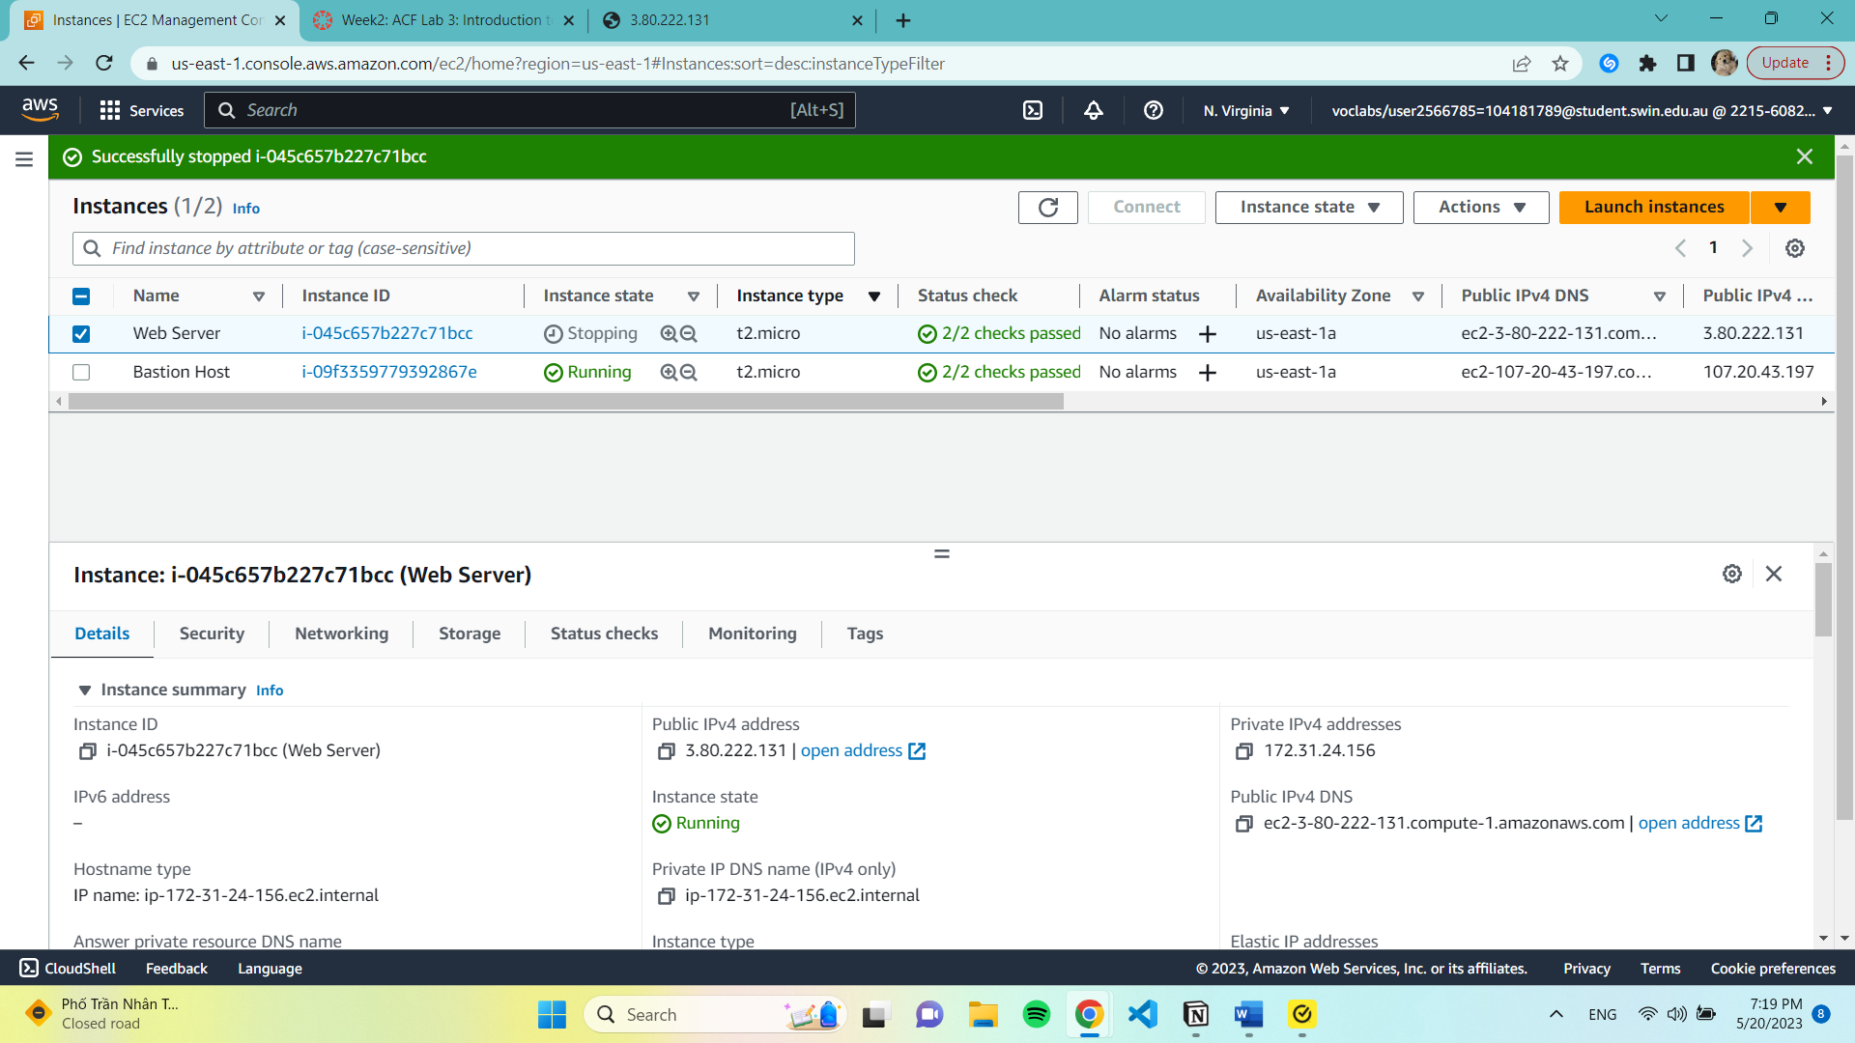

Change The Instance Type

42. Select Instance settings. Change instance typ, then configure:

-Instance Type: t2.small

-Choose Apply

The instance will operate as a t2.small when it is restarted since it contains twice as much RAM as a t2.micro instance.

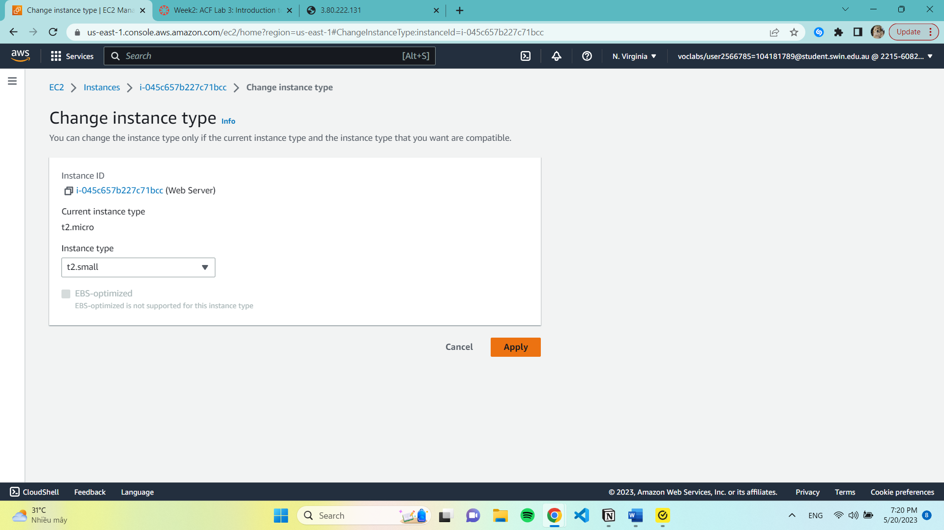

Resize the EBS Volume:

Storage tab -> choose Volume ID then Modify Volume. We change the size of disk from 8 to 10Gb

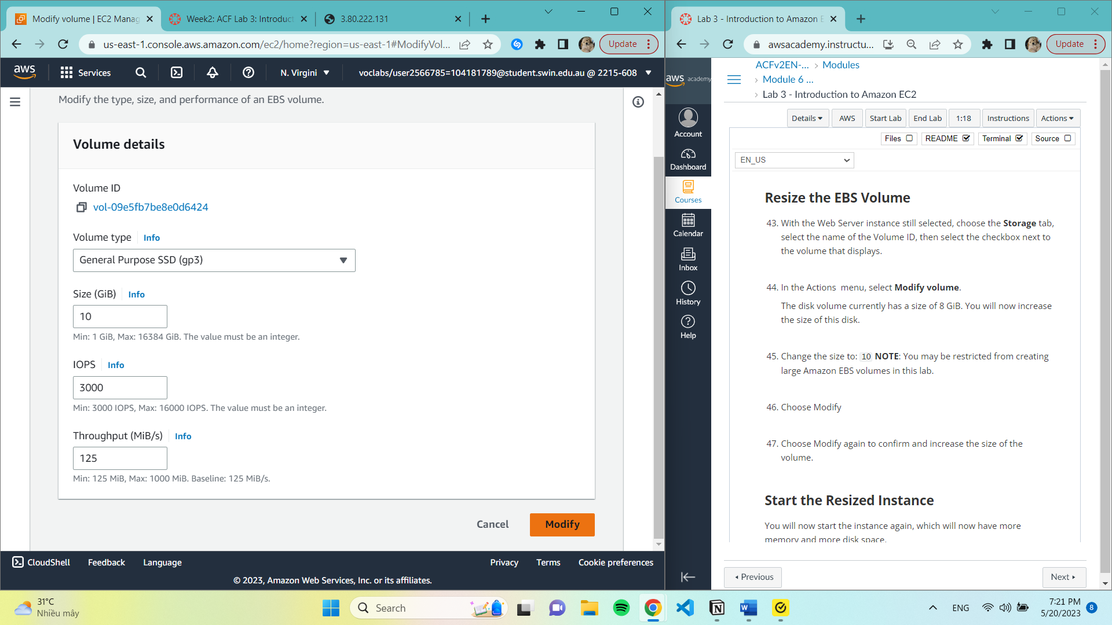

47. Modify again and confirm the change

51. Start Instance.

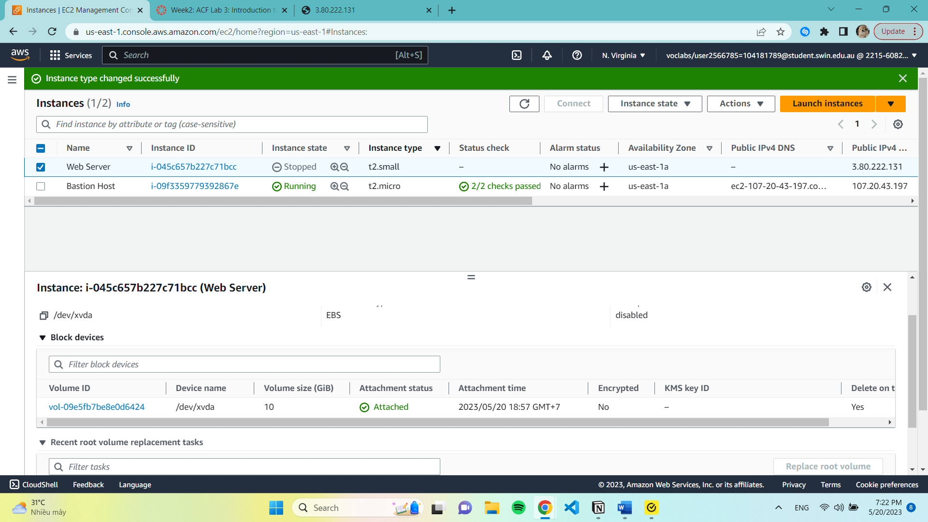

Task 5: Explore EC2 Limits (ignore)

Task 6: Test Termination Protection

57. Select Instance settings -> Change termination protection.

Remove ‘Enable’ check.

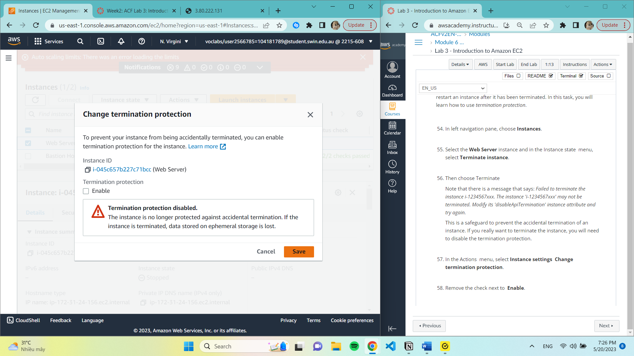

61. Terminate Instance

